**Adding DID to CDD file**

The newly created DID can be added to CDD file.

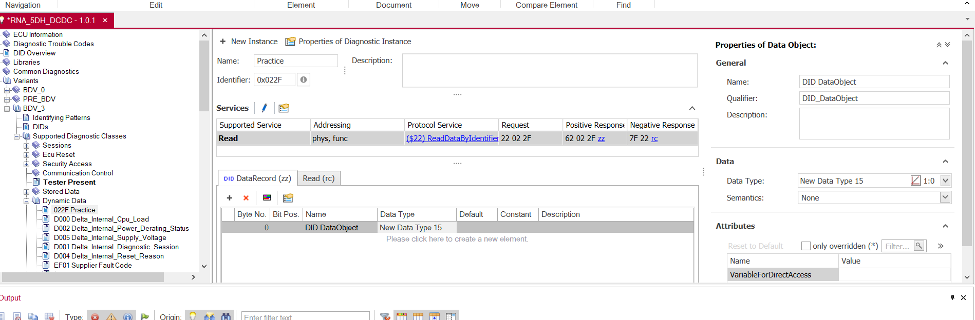

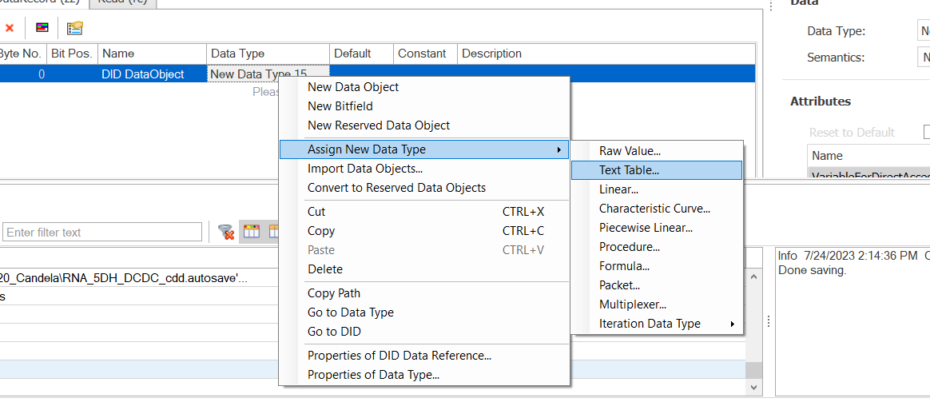

Once you edit the CDD file, replace CDD database in CANOE in tools

Or you can edit the CDD database by opening the database file in CANOE in 70 tools and Save CANoe

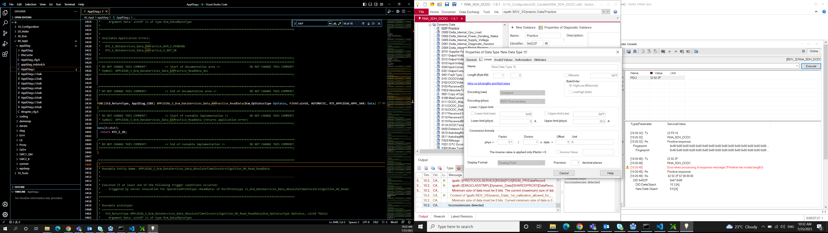

If we are creating a DID with access Read only then mostly add them in Dynamic data while adding them to the CDD file

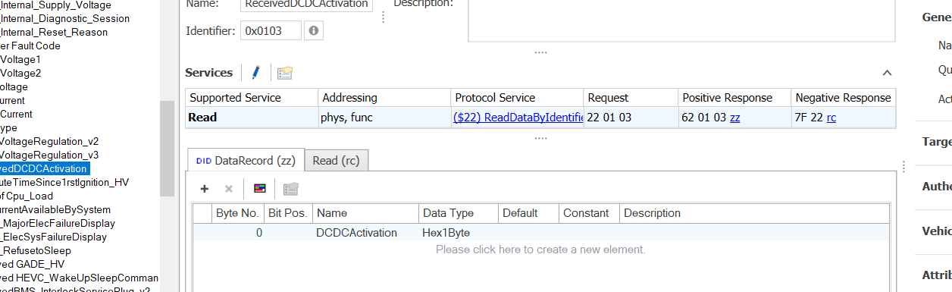

You can see the supported service section

If we are creating a DID with Write (read and write) access, then mostly add them in stored Data while adding them the CDD file

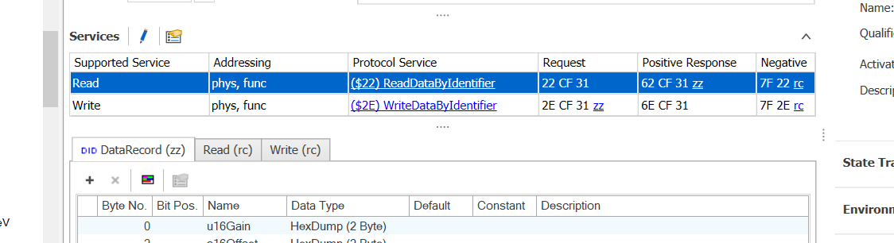

Edit the CDD file from Tools-> CANoe -> Databases, so that the change gets reflected in CANoe [ or else edit in Candela folder in 10_Configuration but we might need to replace the file into database of CANoe]

Here I have added the DID practice in Stored Data which I created in DCM.It will take 4-byte data

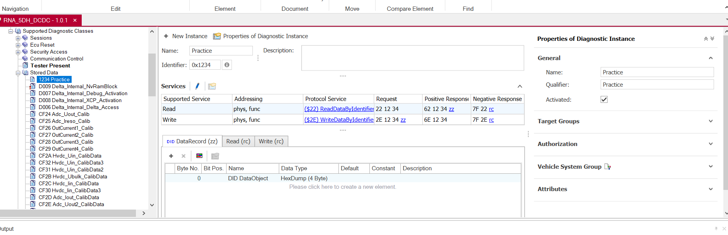

**DID in all Platforms**

Here I consider the DID CF24 Adc_Uout_Calib

In Configurator

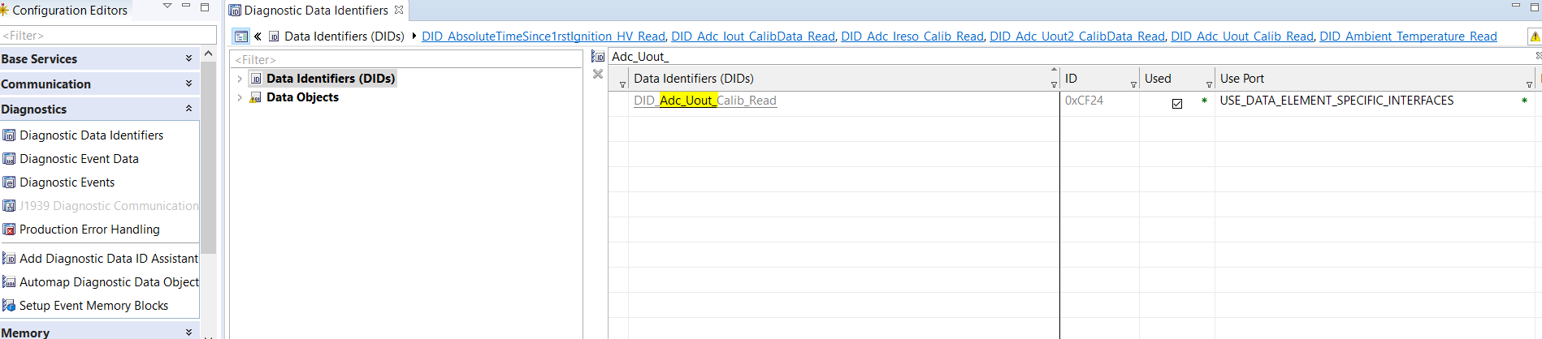

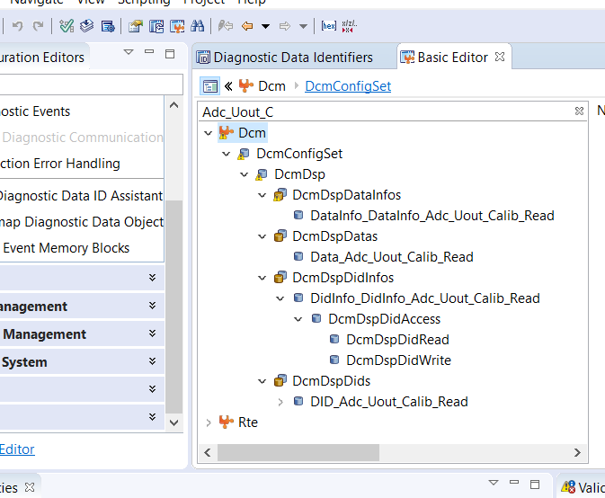

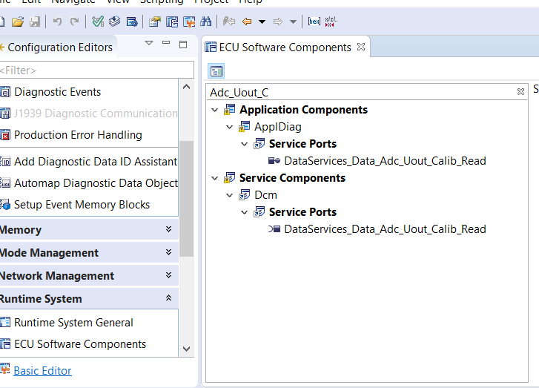

In Developer the SWC Server appldiag will be connected to the Client DCM

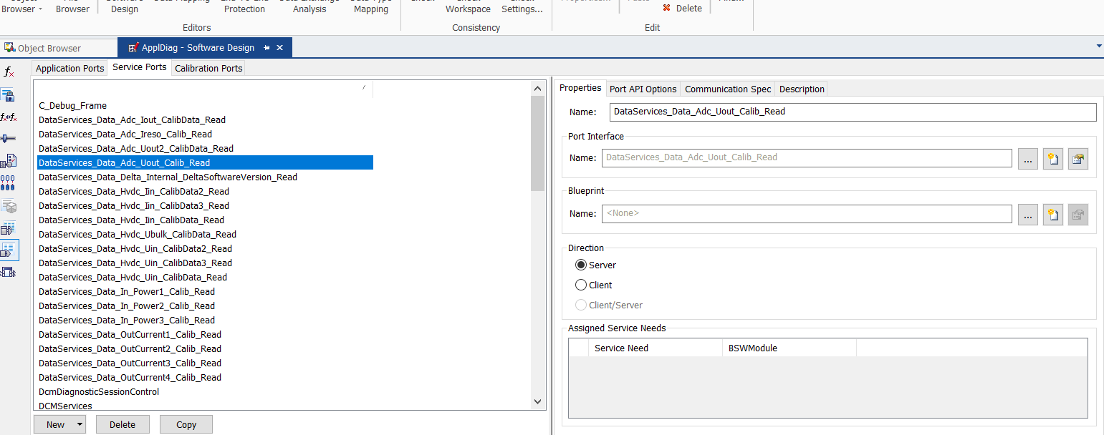

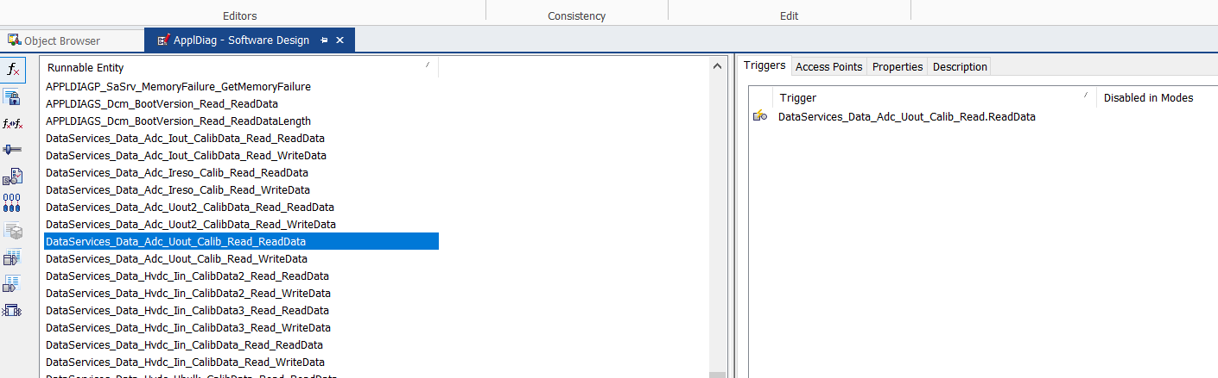

For writing into DID we need to create memory block in NVM so we use coding sheet



Size 2 byte and base type as uint16,sint16

So in Nvm Memory

1 byte Data[1] 1 byte Data[0]

16 bits

1 byte Data[3] 1 byte Data[2]

16 bits

In CDD file, so that it gets reflected in CAN traces with name

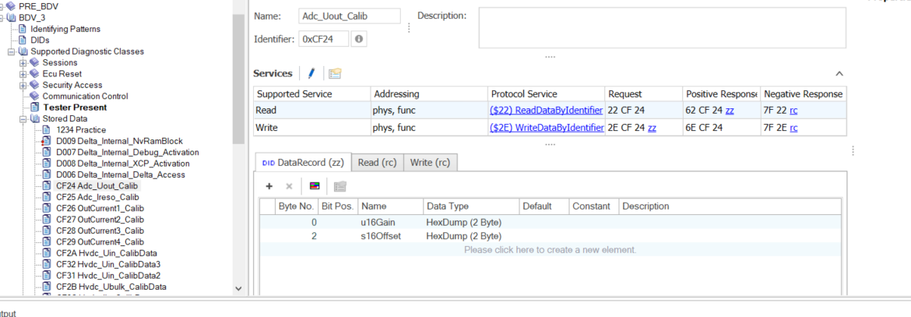

In C file for Appldiag, under the function Adc_Uout_Calib

Write into Memory

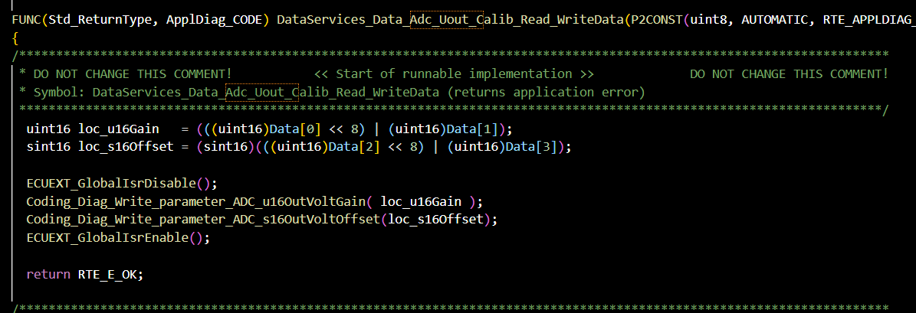

Read from Memory

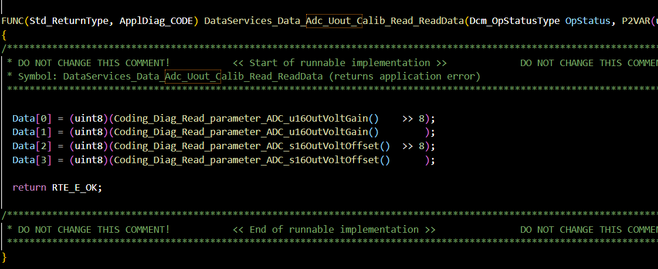

In CANoe

